**Stopper Switch Circuit**

This is a simple circuit we created to test the Door Stopper Switch, which we discovered was a Normally Closed (NC) switch through experimentation. When the button is pressed (i.e. the airlock door is closed), the LED will be off as the switch changes to open and the circuit breaks. When the button is not pressed (i.e. the airlock door is open), the LED will be on, as the switch is closed and the circuit is complete.

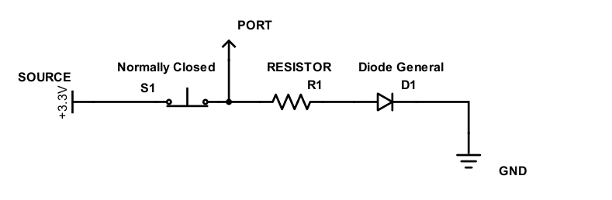

The code we used to test this and print the status to the serial monitor is as follows:

// digital pin 2 has a pushbutton attached to it. Give it a name:

int pushButton = 2;

// the setup routine runs once when you press reset:

void setup() {

// initialize serial communication at 9600 bits per second:

Serial.begin(9600);

// make the pushbutton's pin an input:

pinMode(pushButton, INPUT);

}

// the loop routine runs over and over again forever:

void loop() {

// read the input pin:

int buttonState = digitalRead(pushButton);

// print out the state of the button:

if(buttonState==1){

Serial.print("The door is open\n");

}

else if(buttonState==0){

Serial.print("The door is closed\n");

}

delay(1); // delay in between reads for stability

}